
August 2022

Could you support and inspire 1250 young people?

Do you enjoy public speaking as well as developing strategy?

Mid Glamorgan Scouts are looking for a volunteer with management experience who wants to do more in their community, with excellent inter-personal skills and the ability to motivate, lead and inspire others.

Who are we?

Mid Glamorgan Scouts offer a vibrant, exciting and adventurous co-educational programme for young people aged 6-25 and exciting opportunities (as well as adventure) for adults. We have more than 1250 young people supported by over 440 adults who are involved in local Scout Groups. We are continuing to grow and reach out to more young people and adults. We are looking for someone to take forward this success story.

Who are you?

As Area Commissioner you would be responsible for leading the Scout Area ensuring that we provide good quality Scouting for young people and taking us forward into the future as a growing organisation relevant to young people and adults alike. You are capable of providing strategic direction, working with people of all ages and enabling change.

Are you up for the challenge? We would like to hear from you!

For further information contact:

Rob Redmond – rcsouthwales@scoutscymru.org.uk

For more information about Scouting visit:

www.scoutscymru.org.uk

An application / nomination form for the role is available.

It should be returned, as outlined on the form, by noon on Sunday 21st August 2022.

It is anticipated interviews will be conducted towards the middle of September 2022
Page 1 of 8

Mid Glamorgan Scouts' total membership is over 1250, this includes:

- 296 Beaver Scouts (6 - 8 year olds),  - 453 Cub Scouts (8 - 10½ year olds),  - 380 Scouts (10½ - 14 year olds),  - 94 Explorer Scouts (14 - 18 year olds) | 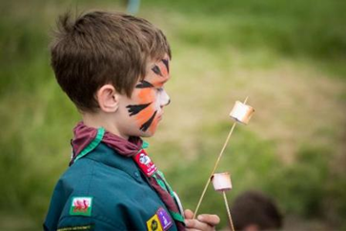
There are 41 Scout Groups based in Glamorgan West.

Activities are offered by Scouting around the UK, made possible by the efforts of more than 100,000 voluntary adult leaders. This has helped to make Scouting the largest coeducational youth movement in the country.

The UK Chief Scout is adventurer Bear Grylls. Each year Scouts spend over two million nights away from home doing adventurous activities. You are never more than 10 miles from a Scout meeting place ensuring adventure is accessible by all.
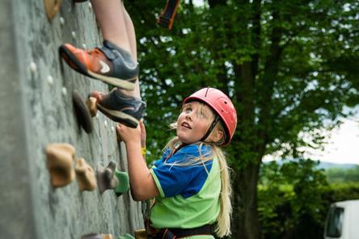

Worldwide Scouting has 28 million members both male and female and operates in nearly every country in the world.

Scouting is all about adventure. In the UK, members can enjoy more than 200 activities including zorbing, water skiing, abseiling and adventure glider flights. So it's easy to see why more and more young people are signing up.
But that's not all. Scouting helps young people achieve their full physical, intellectual, social and spiritual potential as individuals, as responsible citizens and as members of their local, national and international communities.
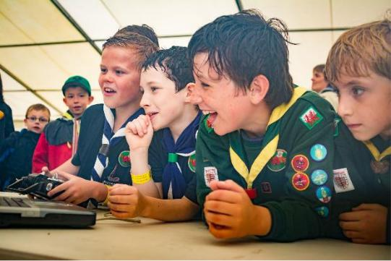

Only Scouting can offer such a range of challenging or exciting activities, available in a safe, supervised environment.


Role Description for
Area Commissioner

Outline: To manage and support the Scout Area to ensure it runs effectively and that Scouting within the Area develops in accordance with the rules and policies of The Scout Association so that that the Area provides good quality Scouting for young people and proactively supports and manages adults in the Area.
Responsible to: Chief Commissioner for Wales.
Responsible for: District Commissioners, Deputy Area Commissioners, Assistant Area Commissioners, Youth Commissioner, Area Network Scout Commissioner, Area Training Manager, Area Scout Active Support Manager(s), Area Scouters, Area Advisers, Area Media Development Manager.
Main contacts: Regional Commissioner, Deputy Area Commissioners, Assistant Area Commissioners, Youth Commissioner, Area Chair, Area Network Scout Commissioner, members of the Area Executive Committee and its sub-committees, District Commissioners, Area Training Manager, Area Scout Active Support Manager(s), Scouting Support Officers, other Area Commissioners, members of the local community, schools and other youth organisations.
Appointment requirements: Must complete the relevant training (a wood badge) within three years of taking up the role. Must be eligible for charity trustee status (as a member of the Area Executive Committee).

Main tasks:
- Ensure that the Area thrives and has the best systems in place to support the Scout Districts, to support all adult volunteers in the Area and to develop Scouting in the Area.
- Provide line management and support to the adults in the Area that directly report to you including setting objectives for their work and holding regular reviews and one-to-one meetings.
- Produce a vision for the Area and implement a development plan to meet that vision.
- Ensure that Scouting in the Area is attractive to young people and adults from all backgrounds in the Area.
- Ensure that the Area has an adequate team of supported and appropriate adults working effectively together and with others to meet the Scouting needs of the area.
- Ensure that problems within the Area are resolved so that excellent Scouting is provided to young people in the Area.
- Work with the Chief Commissioner for Wales and other Area Commissioners to share ideas and implement initiatives to support Scouting in the Area.
Some of the tasks for which the Area Commissioner is responsible may be delegated to others in the Area, including a Deputy Area Commissioner, if appointed. It's expected that whilst volunteering for this role you will undertake regulated activity.

Knowledge and experience
Essential: Ability to manage adults effectively
Desirable:
- Understanding of the challenges of working in the voluntary sector
- Experience of working with young people and/or community work with adult groups
- Experience of working in the Scout or Guide Movement as an adult

Skills
Essential:
- Excellent written and oral communication skills
- Provide advice and guidance effectively to others
- Provide inspirational leadership for the Area
- Provide strategic direction for the Area
- Motivate adults volunteering in the Area
- Build, maintain and facilitate effective working relationships with a wide range of people
- Enable others to identify issues, clarify objectives, develop attainable objectives and gain the necessary skills and confidence to work as an effective team
- Ability to negotiate compromises
- Plan, manage and monitor own tasks and time
- Construct and implement long-term plans that improve and expand the Scouting offered to young people and identify any training, resources and other needs required to undertake this work
- Use basic computer software

Personal Qualities
Essential:
- An understanding of the needs of adult volunteers
- Flexible approach
- Self-motivated
- Able to work as part of a team and promote good teamwork
- Resourceful, energetic and enthusiastic about the job
- Acceptance of the fundamentals of the Scout Movement

Detailed description of the role
The role of Area Commissioner is based around six key areas of leadership and management
1. Providing direction – as an effective Area Commissioner you will be required to:
- Lead by example to promote a co-operative culture of working in the Area.
- Create a vision for the future development of the Area that takes into account the strategic objectives of The Scout Association and Wales.
- Develop a plan to realise the vision for the Area, implement and regularly review it.
- Provide leadership, inspiration and motivation for all adults volunteering in the Area.
- Ensure that everyone in the Area follows the policies and rules of The Scout Association.
- Carry out regular one-to-one meetings and support adults who report directly to you.
2. Working with people – as an effective Area Commissioner you will be required to:
- Develop good working relationships based on trust and Scout values with the adults in the Area and with others in Scouting.
- Manage succession planning and identify the roles that you need to make the Area work effectively and recruit suitable people into those roles.
- Allocate tasks to people within the Area and monitor the progress of those tasks.
- Support adults in the Area Team to develop by completing formal training requirements, learning on the job, trying out new skills and addressing problems affecting performance.
- Build a team spirit in the Area and support the development of the team as a whole.
- Address conflict as it occurs within the Area and reduce the likelihood of it happening through good communication and other methods.
- Run effective team meetings in the Area and participate fully in the Area Executive and Wales Area Commissioner meetings.
- Ensure that adults in the Area perform to agreed standards and if serious problems occur, the correct procedures are followed in consultation with the Chief Commissioner for Wales.
- Appropriately acknowledge good work carried out in the Area (through local events and the national Scout adult award scheme).
- Carry out effective reviews and re-assign or retire people if necessary.
- Build and maintain collaborative relationships with other relevant organisations in the Area’s local area.
3. Achieving results – as an effective Area Commissioner you will be required to:
- Satisfactorily complete projects in the Area for which you are responsible.
- Ensure that all the initiatives in the Area are managed appropriately.
- Ensure that there are appropriate processes in place within the Area so that Scouting is delivered effectively to young people.
- With the Area Executive Committee and the Area Team ensure that Scouting is promoted locally.
- Build up an understanding of the young people in your local area and ensure that Scouting is promoted effectively to them, including focusing on their needs and expectations.
- Monitor and review the progress that District Commissioners are making against their targets and development plans.
- Have a robust Area development plan in place and regularly review progress.
- Satisfactorily resolve problems and issues raised by adult and youth members of the Area and by parents or carers of youth members in the Area.
- Continually improve the performance of all elements of Scouting within the Area
4. Enabling change – as an effective Area Commissioner you will be required to:
- Support and encourage adults in the Area to think of new and creative ways to improve Scouting within the Area.
- Be enthusiastic about new ideas, give constructive feedback on those ideas and encourage and support further work on them.
- Communicate your vision for the future of the Area and lead people through changes that this vision requires.
- Develop effective plans to implement change and then carry them out, working together with relevant members of the Area.
- Recognise the contribution of others towards change and improvement.
5. Using resources – as an effective Area Commissioner you will be required to:
- As part of the Area Executive Committee, ensure that appropriate financial measures are in place.
- As part of the Area Executive Committee, ensure that there is an adequate income for the Area including the identification of other income sources such as grants.
- Ensure that the health and safety of everyone involved in Scouting within the Area is properly managed at all levels.
- Work with the Area Executive Committee and the Area Team to ensure that the Area has sufficient physical resources to support its work with youth members.
- Work with the Area Executive Committee and the Area Team to minimise the negative impact and maximise the positive impact that the Area has on the environment.
- Make decisions about matters within the Area based on the best available information.
- Ensure that key knowledge within the Area is properly managed and used to improve the operation of Scouting within the Area.
- Provide resources, support and encouragement for teams of volunteers within the Area to work in many ways.
6. Managing your time and personal skills – as an effective Area Commissioner you will be required to:
- Agree realistic goals and targets with the Regional Commissioner for the development of the Area that work towards The Scout Association’s strategic objectives.
- Consider the future requirements of your role then identify the skills and knowledge that you need to develop or improve and the steps you will follow to do so.
- Regularly check how you use your time and identify possible improvements so that you focus on the goals and priorities that you have agreed with the Regional Commissioner.
- Ask other adult volunteers for feedback about how you carry out your role and act on it.
- Attend National and Wales Area Commissioner meetings and events.

