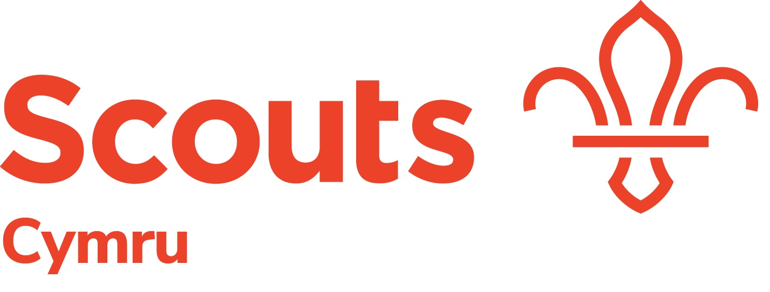

Role Description –Programme Team Member - Beavers

Overview
For our Programme Team Member - Beavers, we’re looking for someone with the ability to motivate
and communicate well. As Programme Team Member for Beavers, you will be responsible for providing
support to development of the programme for Beavers and providing support to Areas and Districts with respect to the section supported.

Main Tasks
- Work with the Area and District Teams to make sure that there is a fun, inclusive and age-appropriate programme, for Beaver aged young people, which is consistent across Wales.
- Advise Beaver Leads, Area and Region Lead Volunteers on matters relating to the Beavers section
- Be a part of the Wales Programme Team and attend meetings, including District, Area and National Events as required.
- Organise meetings for Area Beaver Leads to share best practice and identify opportunities to work together.
- Encourage Beaver Leads and any Area Leads for Programme, to work together to organise and run a wide programme of activities for Scouts.
- Keep up to date with information about 6-8-year-olds and what things are happening in local communities, across Wales, which might be relevant to Beavers.
- Support the review and development of the ScoutsCymru badges as and when required.
- Working with Area Programme Teams and ScoutsCymru Event Lead to ensure a programme of events for Beaver Section Members

Responsible to Wales Lead Volunteer - Programme

Main Contacts ScoutsCymru Senior Leadership Team
ScoutsCymru Leadership Team
Area Programme Teams
Other members of Programme Team
UK Lead for Beavers
UK Programme Team

Person Specification
- Have a good understanding of the planning and delivery of sectional youth programmes
- Understand the importance of high-quality community impact projects and programmes in fulfilling the national strategy
- Be able to build a positive and active relationship with others
- Be enthusiastic, proactive and able to enthuse others about high quality programmes
- Willingness to travel across the Wales (although much of the role can be undertaken remotely) and have the time necessary to undertake the role effectively.
- Be able to lead project teams
- Have good written and oral communication skills
- Have excellent computer and digital skills
- Be able to work well in meetings
- Possess good presenting and facilitating skills
- Be articulate
- Confident public speaker
- Accept the policies and rules of The Scout Association
- Be willing to become a member, take The Scout Association Promise and wear the Scout Uniform
- Accept and promote Scouting's fundamentals and the implementation of the youth programme

